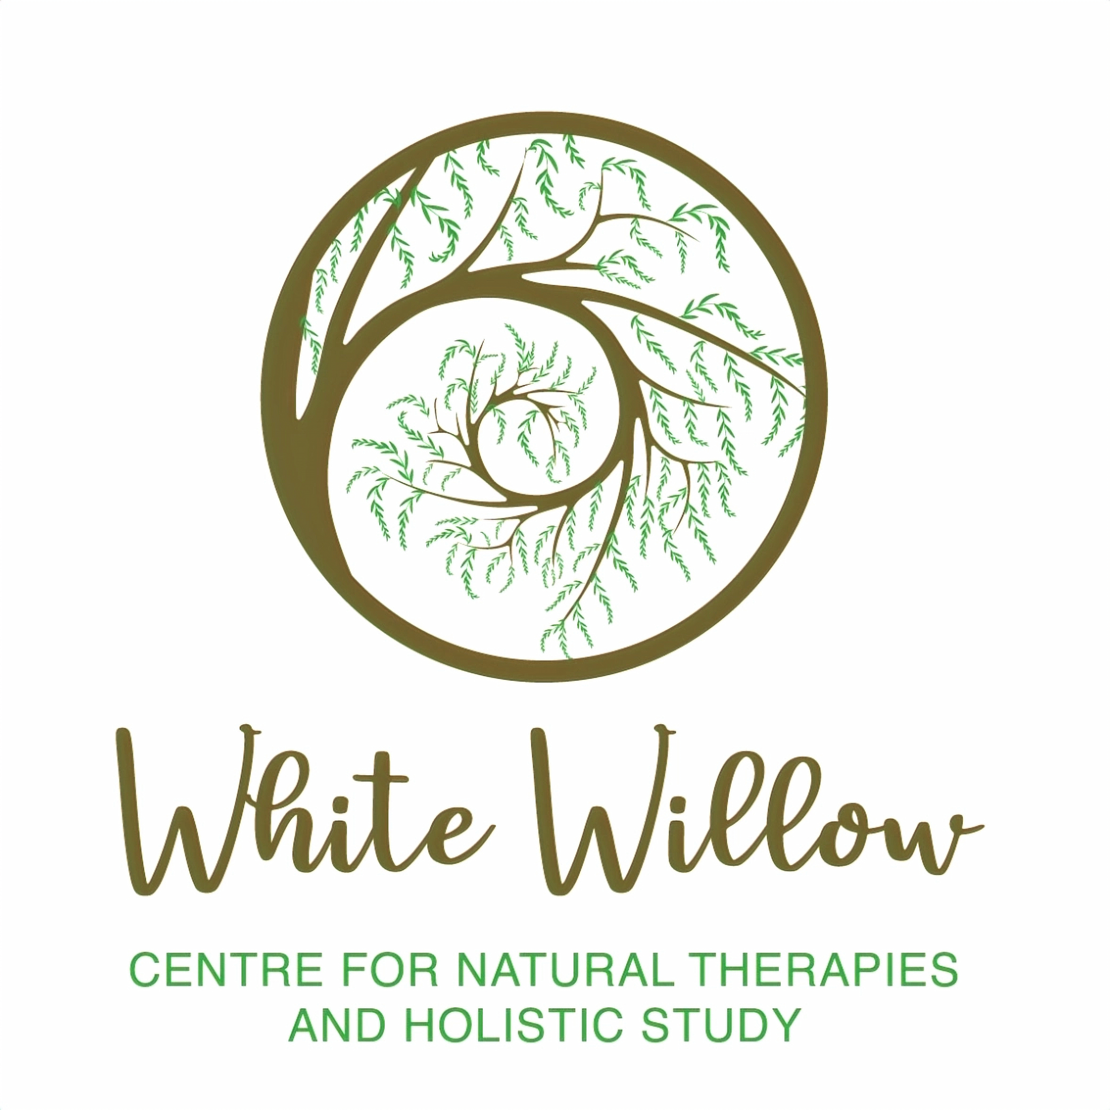

Reflexology Certification Training



SUDBURY ONTARIO

WHERE: White Willow Centre Sudbury Location

Call or Text: 705-920-1935

When: May 3-4 Followed by a 2nd weekend of training (TBA)

It’s not too late to enroll! ENROLL TODAY!

Reflexology is an ancient practice that involves applying pressure to specific points on the feet to promote healing and improve overall wellness. Whether you are a seasoned practitioner or a newcomer to the field, our Reflexology Certification Training Course offers a comprehensive program designed to enhance your skills and knowledge.